**LAB # 08**

**“ CLASSIFICATIONS USING NEURAL NETWORKS ”**

* **OBJECTIVE:**

Classifications using neural networks is a fundamental task in deep learning where the goal is to assign a label or category to an input based on its features.objective of this Lab is to build a neural network using TensorFlow and Keras that classifies tumors in the Breast Cancer dataset as malignant (1) or benign (0).

* **LAB TASKS:**
* **CODE:**

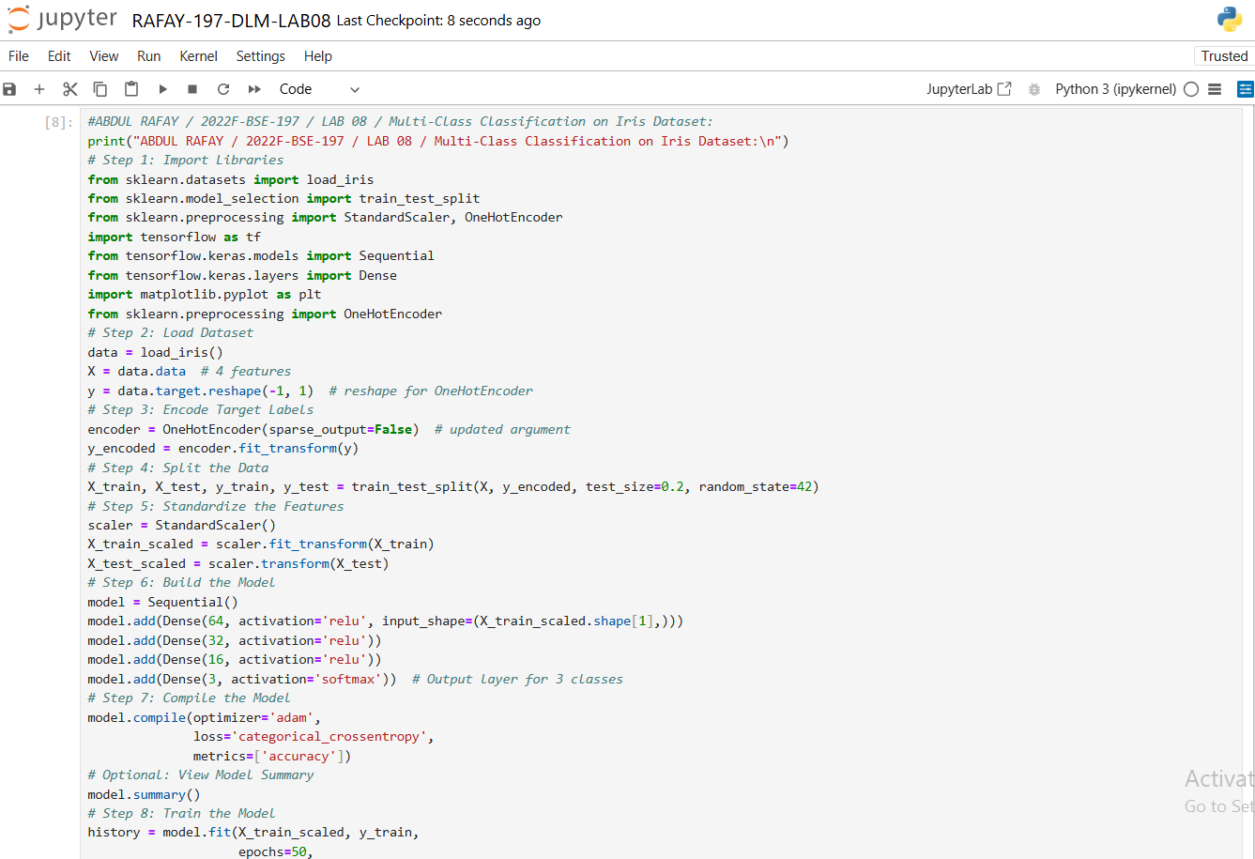

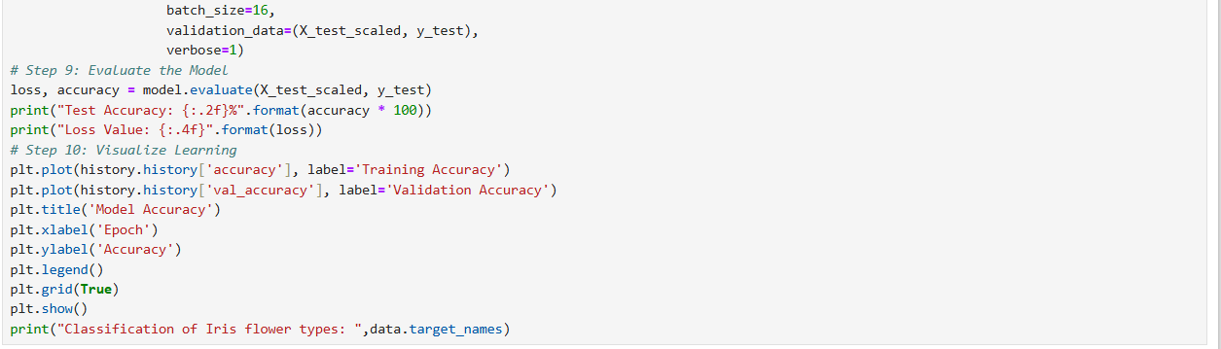

* **OUTPUT:**

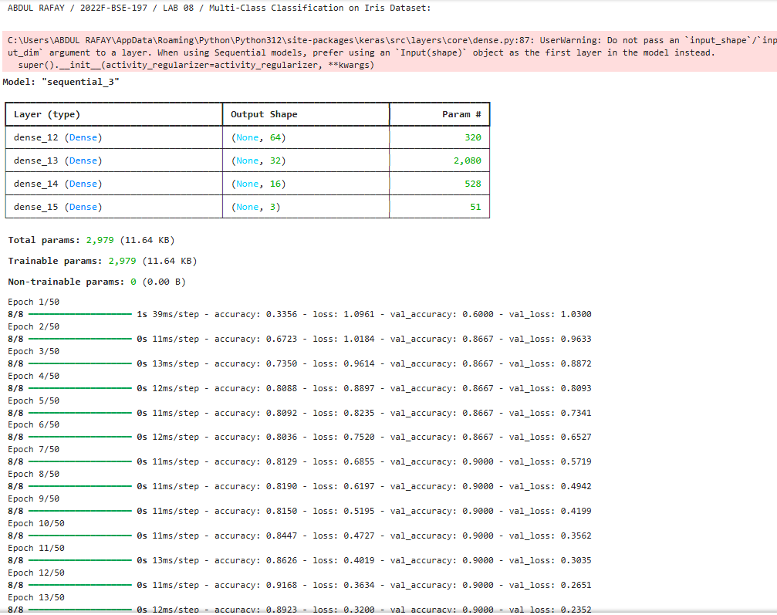

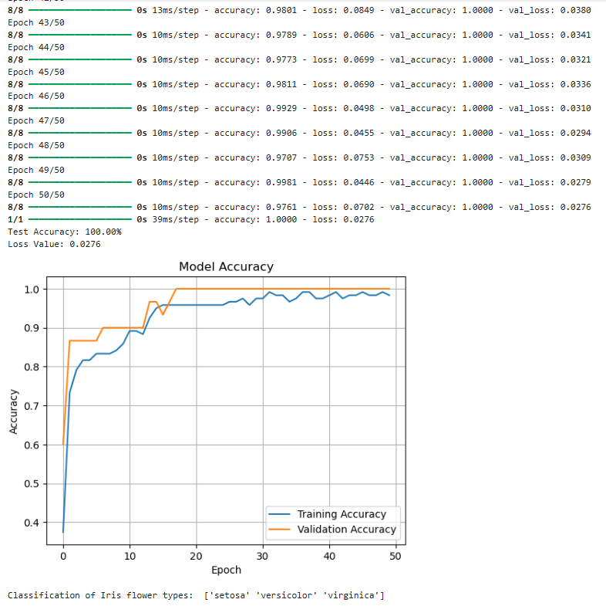

* **GITHUB UPLOAD:**
* **KAGGLE UPLOAD:**